- Danabooks-Airtable-sync
(GitHub repo - Ahsana-fragrantsouq / Danabooks-airtable-sync)

1. Overview:
This service keeps the Cost field on the French Inventories table in Airtable in sync with the latest purchase prices recorded in Danabooks. It runs as a Flask web service on Render. (Update cost field in French inventories table automatically)
2. What It Needs to Run:
DANABOOKS_TOKEN | Login key for Dana Books. Without this, the sync won't run.
AIRTABLE_API_KEY | Login key for Airtable.
AIRTABLE_BASE_ID | Which Airtable base to update (already set to the main Fragrant Souq base).

3. How It Works:
- It looks at every product in Airtable that has a SKU.
- It asks Dana Books: "what was the last purchase price for this SKU?"
- If Dana Books has no price for it — skip, leave Airtable alone.
- If the price is the same as what's already in Airtable — skip, nothing to do.
- If the price is new or different — update the Cost field in Airtable.
[It does this in batches (500 products at a time) so it doesn't overload either system, and it automatically retries if Dana Books is slow or briefly unavailable.]
4. Scheduled times: 9AM, 2PM, 8PM
5. Run it manually: To sync everything: https://danabooks-airtable-sync.onrender.com /sync-all
6. Logs (render):
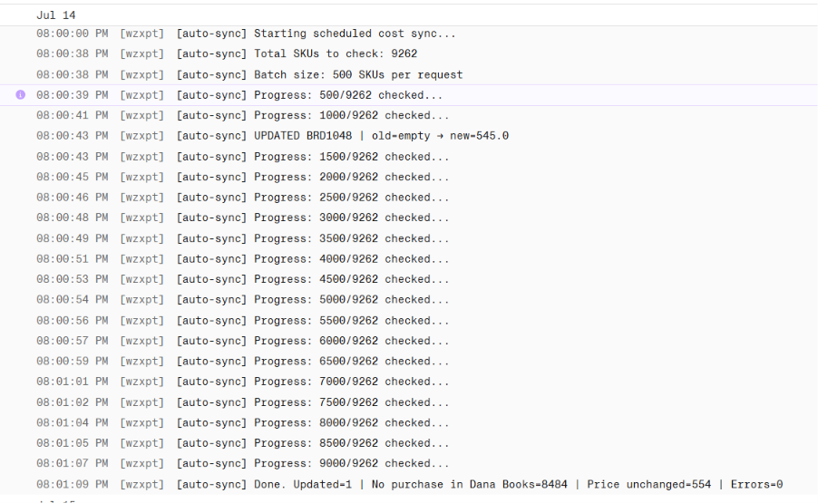

- session-report-slack
(GitHub repo - Ahsana-fragrantsouq / session-report-slack-)

- Overview:
Every day, this service pulls yesterday's website traffic from Shopify — specifically, how many visitors and sessions each product page got — and posts it as an Excel file to Slack (Session – channel). It only reports on product pages, not the homepage, collections, or other page types. (It’s an automatic daily report so the team can see which products are getting the most traffic, without anyone pulling the numbers by hand.)
2. What It Needs to Run:
SHOPIFY_ACCESS_TOKEN | Login key for Shopify, used to pull the traffic numbers.
SLACK_BOT_TOKEN | Login key for Slack, used to post the report.
SLACK_CHANNEL_ID | Which Slack channel gets the report (defaults to the #session channel).

3. How It Works:
•It asks Shopify for yesterday's visitor and session numbers, grouped by landing page.
• It keeps only product pages.
•It builds a neatly formatted Excel file with three columns: page, visitors, and sessions.
• It uploads that file to Slack, with a short summary message showing how many product pages were included.
4. Scheduled time: 5PM
5. Run it manually:
•To run yesterday's report right now: https://session-report-slack.onrender.com /run-now
•To run a report for a specific date: https://session-report-slack.onrender.comrun-date/2026-06-07 (replace with the date you want)
•To check if the service is alive: https://session-report-slack.onrender.com/health
6. Output (slack): 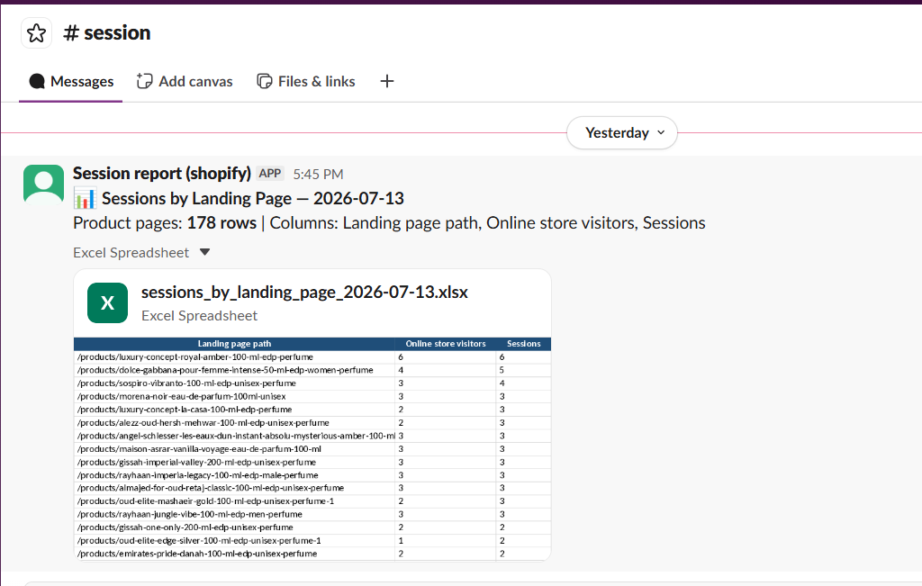

- airtable-sync-(4)
(GitHub repo - Ahsana-fragrantsouq / airtable-sync-4)
[Does four separate jobs combined into a single app.]
• Delivery Tracker — checks Professional Courier for delivery status and marks Shopify orders as Delivered.
• Amazon Sync — pulls Amazon orders into Airtable (Customers, Orders, and Order Line Items).
• Trendyol Sync — does the same thing, but for Trendyol orders.
• Abandoned Cart — when someone starts checkout on Shopify but doesn't finish, this saves them as a Lead in Airtable (lead table) so the team can follow up.

- Delivery Tracker

- Overview:
It looks at Shopify orders shipped with courier 'Other' and a tracking number, checks Professional Courier's website for the delivery status, and marks the order “Delivered” in Shopify if it's arrived.
- How It Works:
- Gets triggered by Shopify Flow at 9 AM and 6 PM (or manually via /check-tracking).
- Pulls all Shopify orders that are marked "shipped."
- Filters down to only the ones where: carrier = "Other" (this is how Professional Courier orders are tagged), there's a tracking number, and it's not already marked delivered.
- For each of those, it visits professionalcourier.ae, submits the tracking number into their tracking form, and reads back the result page.
- It looks for a "Current Status" column in the results table — if that's not there, it falls back to scanning the page text for keywords like "delivered," "in transit," etc.
- Only if the status is exactly "delivered," "delivery complete," or "successfully delivered" does it mark the order Delivered in Shopify. Anything else (even "out for delivery") is left alone.
- Scheduled time: 9AM and 6PM
- Manual run: https://airtable-sync-4.onrender.com/check-tracking
(Note: only orders where the carrier is set to 'Other' are checked — this is intentional, since that's how Professional Courier shipments are tagged in Shopify.)

- Amazon Sync

- Overview:
Pulls recent orders from Amazon Seller Central and creates or updates matching Customer, Order, and Order Line Item records in Airtable, so Amazon sales show up alongside Shopify and Trendyol sales.
- How It Works:
- An Airtable Automation, runs a script that:
- Wakes the Render service (GET /) since it sleeps when idle on the Starter plan.
- Polls up to 20 times until it responds.
- Calls GET /ping with a secret header (X-Update-Secret) that must match Render's UPDATE_SECRET.
- Retries up to 3 times if that call fails.
- Once /ping fires, inside Render:
- Logs into Amazon with a refresh token.
- Pulls the last 2 days of orders.
- For each order: finds or creates the Customer (matched by Amazon ID → email → phone, in that order).
- Creates/updates the Order record.
- Pulls line items, matches each to a product by SKU, and creates/updates Order Line Items.
- Scheduled time: Every 12 hours
- Manual run: https://airtable-sync-4.onrender.com/sync-all

- Trendyol Sync

- Overview:
The same idea as the Amazon sync, but pulls orders from Trendyol instead.
- How It Works:
- Airtable Automation, wake → poll → trigger pattern — just calling /ping/Trendyol instead.
Once triggered:
- Authenticates to Trendyol via API key/secret.
- Fetches recent orders (50 at a time).
- Finds/creates the Customer by Trendyol ID.
- Finds/creates the Order, including a Ship by date from Trendyol's estimated delivery.
- Matches each line item to a product by merchantSku, then creates or updates it.
- Scheduled time: Every 12 hours
- Manual run: Sync recent orders: https://airtable-sync-4.onrender.com/ping/trendyol (requires a secret key)
- Fill in missing 'Ship By' dates for all past orders: https://airtable-sync-4.onrender.com/backfill-ship-by/trendyol

- Abandoned Cart

1. Overview:
Whenever a shopper starts checking out on Shopify but doesn't complete the order, this saves their details as a Lead in Airtable in Lead table (with whatever products they were about to buy), so the sales team can reach out.
- How It Works:
- A real Shopify webhook — fires instantly the moment someone starts checkout.
- Verifies the request actually came from Shopify (HMAC signature check).
- Skips if the checkout was completed, or if there's no email/phone.
- Finds or creates the Customer by phone/email in airtable.
- Matches cart items to products by SKU — if nothing matches, no Lead is created.
- If there's at least one match, creates a Lead record linking the customer and matched products.
- Scheduled time: automatically and instantly, triggered by a Shopify webhook every time a checkout starts.
- Manual run: https://airtable-sync-4.onrender.com/sync/abandoned-checkouts

- Shopify-airtable-integration
(GitHub repo - Ahsana-fragrantsouq / shopify-airtable-integration)

  - Overview:
This service keeps Airtable's Orders, Order Line Items, and Customers tables automatically in sync with Shopify. Instead of checking Shopify on a timer, it listens for events — new orders, shipments, cancellations, and edits — and updates Airtable the moment they happen.
  - What It Needs to Run:
AIRTABLE_TOKEN | Login key for Airtable, used to read and write Orders, Customers, and Line Items.
SHOPIFY_WEBHOOK_SECRET | Confirms incoming webhooks really came from Shopify, not somewhere else.
SHOPIFY_STORE | Your Shopify store name, used for the manual full-sync feature.
SHOPIFY_TOKEN | Shopify Admin API key, also used for the manual full-sync feature.

  - How It Works:
- New order placed
Shopify sends a signal the moment an order is placed. The service finds or creates the customer (matched by WhatsApp number or email), creates the Order record, then creates one Order Line Item per product — matching each product to French Inventories by SKU. If the order already exists, it's skipped to avoid duplicates.
- Order shipped / fulfilled
Shopify sends a signal when a fulfillment happens. The service works out the correct status — Delivered, Shipped, or Fulfilled — and updates it on the Order record and every one of its line items.
- Order cancelled
Shopify sends a signal when an order is cancelled. The service marks that order's Shipping Status as cancelled everywhere it appears in Airtable.
- Order edited or status changed
Shopify sends a signal whenever an order is updated. The service re-checks the payment and shipping status and refreshes both the Order record and its line items to match.
  - Manual run: https://shopify-airtable-integration-qtq4.onrender.com/sync to pull every order from Shopify and bring Airtable fully up to date.
  - Logs: 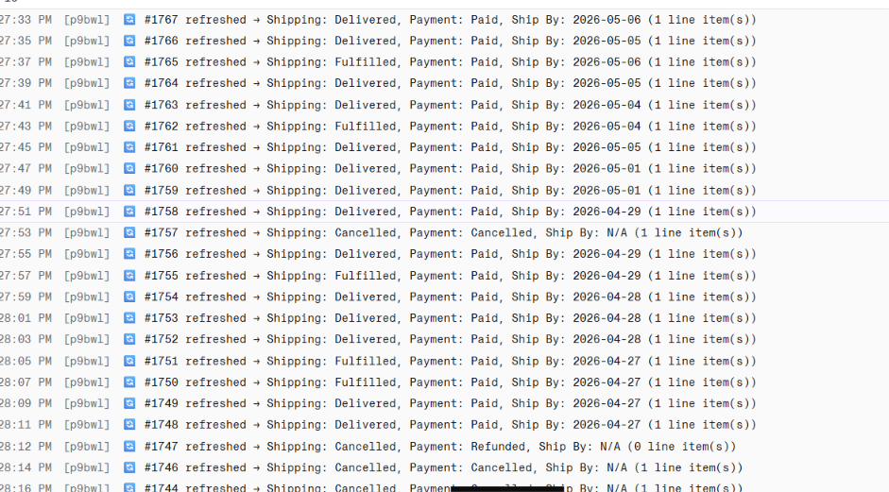

- Syncing my price
(GitHub repo - Ahsana-fragrantsouq / Shopify-airtable)

  - Overview:
This service pushes product updates from Airtable into Shopify. Whenever a product's price, quantity, title, barcode, or size changes in Airtable, this service finds the matching product in Shopify (by SKU) and updates it there too — including the price shown in each regional market (UAE, Asia, America).
  - What It Needs to Run:
SHOPIFY_SHOP | Your Shopify store's address, used to know which store to update.
SHOPIFY_CLIENT_ID / SHOPIFY_CLIENT_SECRET | Shopify app credentials — used to log in and get an access token automatically.
WEBHOOK_SECRET | A password Airtable must send along with every update, so random visitors can't trigger changes.

  - How It Works:
- Airtable sends this service a product's latest details — SKU, title, barcode, size, prices for each market, quantity — whenever something changes.
- The service checks the request included the correct secret password; if not, it's rejected.
- It looks up the matching product in Shopify using the SKU.
- If the SKU isn't found in Shopify at all, it stops there and reports "Variant not found" — nothing else is updated.
- If a title or barcode was sent, it updates those on the product in Shopify.
- If a size was sent, it saves it as a product detail (metafield) in Shopify.
- If a UAE price was sent, it updates the product's default price in Shopify.
- If a quantity was sent, it updates the stock count at the main warehouse location.
- For every market price that was sent (UAE, Asia, America), it also updates that market's specific price list in Shopify, so customers in each region see the right price.
  - Logs:
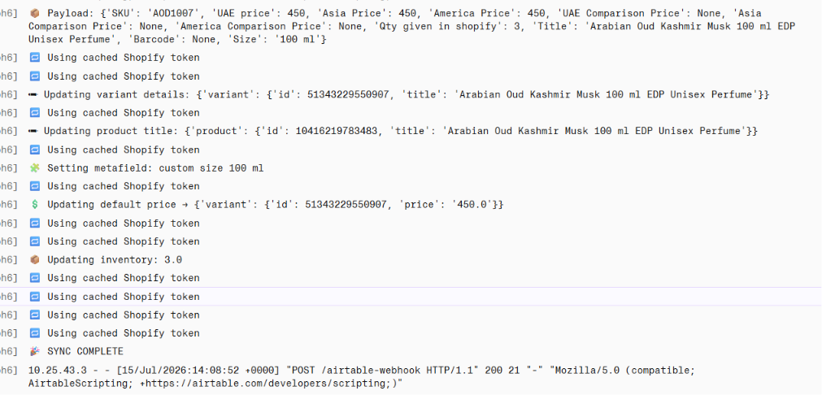
- whatsapp-airtable-sync
(GitHub repo - Ahsana-fragrantsouq / whatsapp-airtable-sync)

  - Overview:
- This service connects directly to a WhatsApp Business number and turns real customer conversations into structured Leads in Airtable — automatically. It watches both sides of the chat (customer messages and agent replies), waits until the conversation goes quiet, then uses Claude AI to summarize what happened and saves that summary as a Lead.
- It also has a one-time "backfill" mode that can go back through old WhatsApp chat history and turn past conversations into Leads too, so nothing from before this was set up gets lost.
  - What It Needs to Run:
AIRTABLE_API_KEY / AIRTABLE_BASE_ID | Airtable login — used to read and write Leads and Customers.
AIRTABLE_TABLE_NAME / AIRTABLE_CUSTOMER_TABLE | Which Airtable tables to save into (defaults to "Lead table" and "Customers").
ANTHROPIC_API_KEY | Claude login — used to summarize each conversation into a lead.
INACTIVITY_MINUTES | How long to wait after the last message before summarizing a chat (defaults to 30 minutes).

  - How It Works :
  - A customer messages the WhatsApp number, or an agent replies to one — both directions are captured.
  - Messages for that phone number are collected together into one running conversation.
  - Every new message resets a timer. If no new message arrives for the configured inactivity period (default 30 minutes), the conversation is considered "done" for now.
- The full conversation transcript is sent to Claude, which extracts the customer's name, email (if mentioned), a short summary of the session, their main product interest, and a lead status (hot, warm, cold, or not a lead).
- The service finds or creates a matching Customer record in Airtable (matched by WhatsApp number).
- It tries to match the customer's stated interest to a real product in French Inventories by name, so the Lead can be linked to actual products.
- If a Lead already exists for that customer, it updates the "latest summary" and appends to the running "all-time summary" with a date. If not, it creates a new Lead record.
  - Manual run :
For historical chats backfill: https://whatsapp-airtable-sync.onrender.com/backfill
  - Connecting WhatsApp (First-Time Setup) :
• https://whatsapp-airtable-sync.onrender.com/qr on the service's web address.
•Scan the QR code shown there using WhatsApp → Linked Devices → Link a Device, on the phone with the business number.
•Once connected, the page will show "connected" status and you won't need to scan again — the login is saved to the persistent disk.
•If the service ever asks for a fresh QR scan unexpectedly, it usually means the persistent disk was reset or the session was invalidated from the phone's side (e.g. WhatsApp was unlinked manually).
  - Addition to code:
Added a code for warning message in slack, when whatsapp got disconnected.
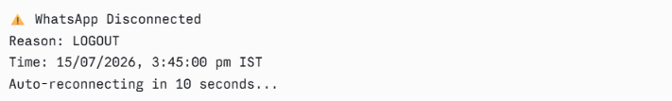

  - Logs :
